Name : K.AravindRoyal

Trainer Name:- Harshee pithoda

Course Name:-python for machine learning

Date:-25/05/2022

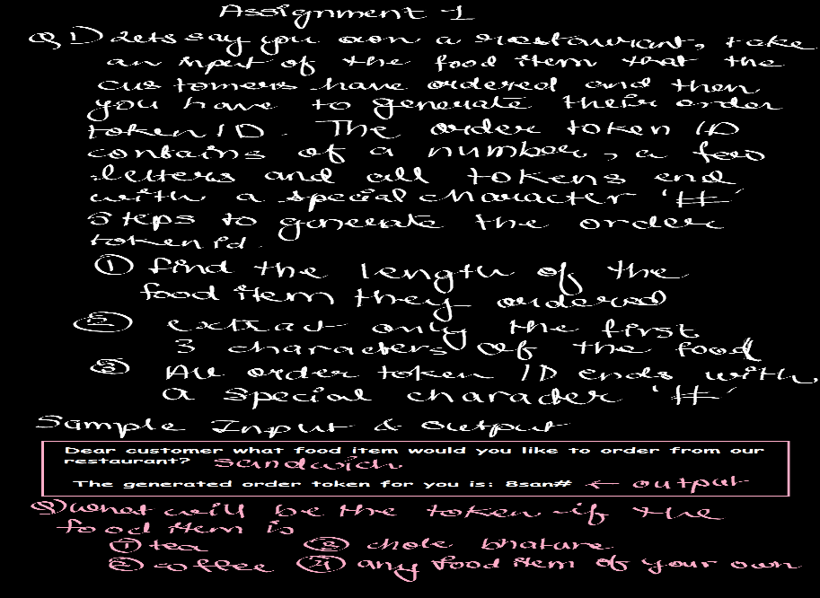

a=str(input("Dear customer what food item would you like to order from our restaurant"))

b=len(a)

e=str(b)

c=a[:3]

d="#"

print(" The generated order token for you is:",e+c+d)

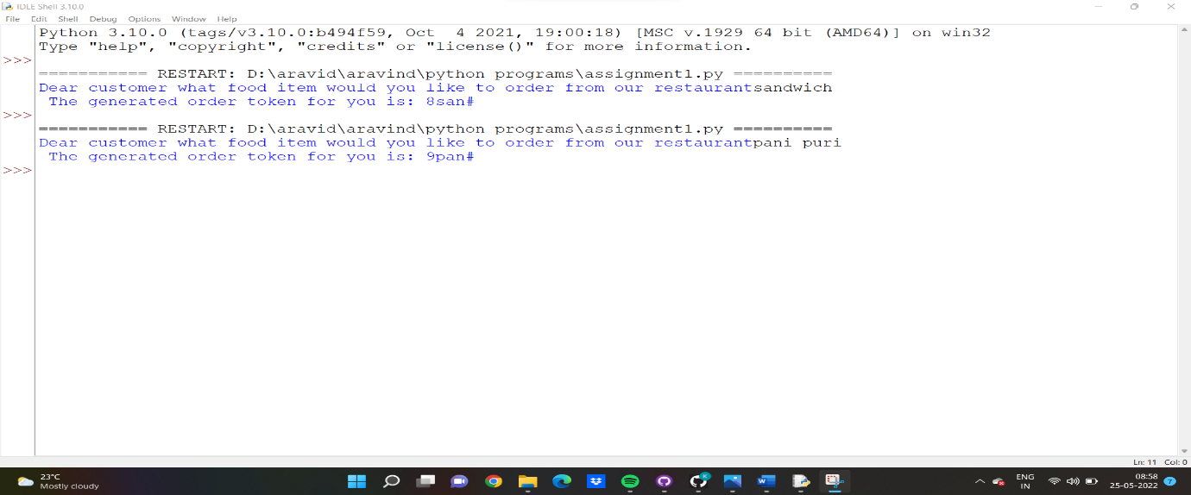

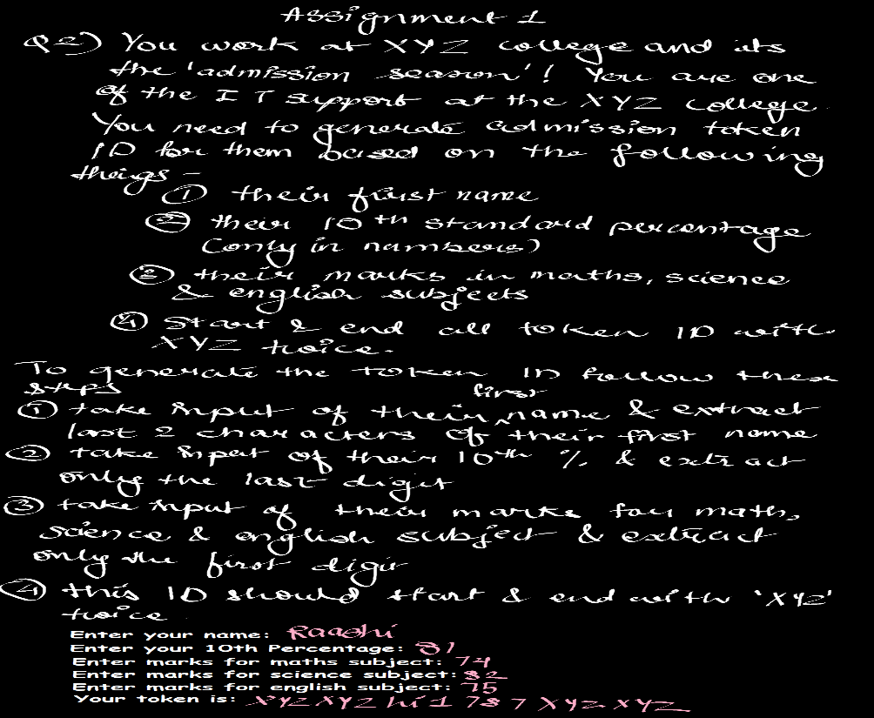

a='xyz'#CLG

b=str(input('Enter your name:'))

c=str(input('Enter your 10th percentage:'))

d=str(input('Enter marks for maths subject:'))

e=str(input('Enter marks for science subject:'))

f=str(input('Enter marks for english subject:'))

print(a+a+b[-2:]+c[-1]+d[0]+e[0]+f[0]+a+a)

